Stream:
Sequence of data is called stream. There are two types of Streams:
- InPutStream: The InputStream is used to read data from a source.
- OutPutStream: The OutputStream is used for writing data to a destination.
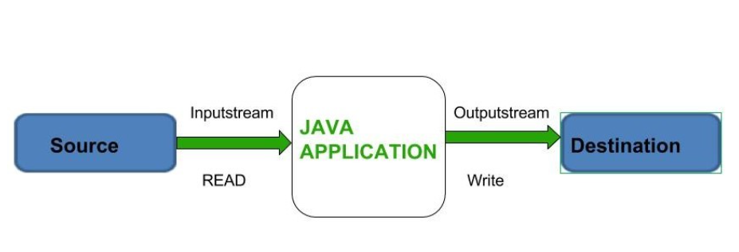
Input and output streams in Java provide a way to read from and write to various data sources and destinations, such as files, network connections, and in-memory buffers. The streams are a fundamental part of Java I/O (Input/Output) and are based on the abstract classes InputStream and OutputStream.

IO Class Hierarchy
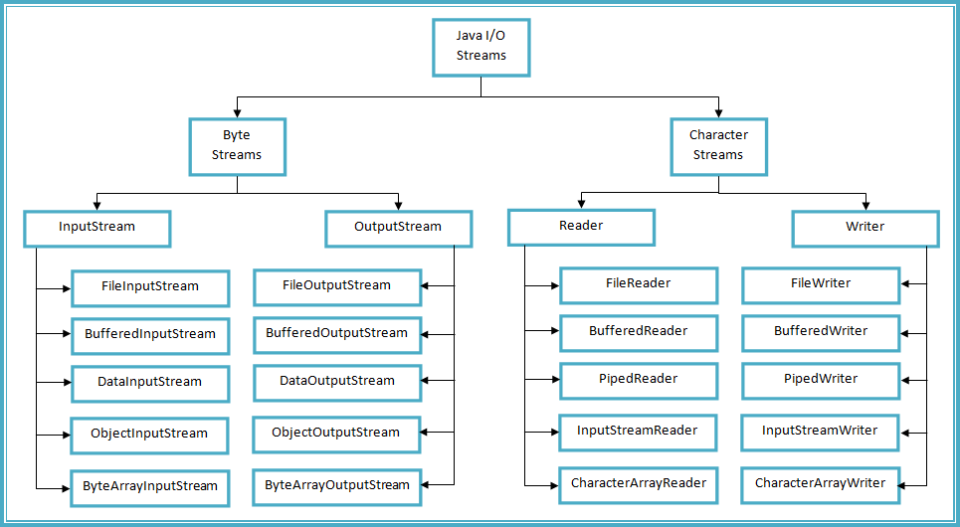

ByteStreams:
Byte streams in Java handle I/O operations at the byte level. They are primarily used for reading and writing binary data, such as images, audio files, or any other non-textual data. Byte streams work with the InputStream and OutputStream classes
Types of ByteStream:
ByteStreams can be divided into two primary classes:
- Input Stream: These streams are used to read data that must be taken as an input from a source array or file or any peripheral device. For eg., FileInputStream, BufferedInputStream, ByteArrayInputStream etc.

- Output Stream: These streams are used to write data as outputs into an array or file or any output peripheral device. For eg., FileOutputStream, BufferedOutputStream, ByteArrayOutputStream etc.

InputStream:
- FileInputStream: Reads data from a file as a sequence of bytes.
- ByteArrayInputStream: Reads data from a byte array.
- BufferedInputStream: Provides buffering capabilities to improve input performance.
- DataInputStream: Reads primitive Java data types from an underlying input stream.
- ObjectInputStream: Reads objects from an underlying input stream, including serialized objects.
OutputStream:
- FileOutputStream: Writes data to a file as a sequence of bytes.
- ByteArrayOutputStream: Writes data to a byte array.
- BufferedOutputStream: Provides buffering capabilities to improve output performance.
- DataOutputStream: Writes primitive Java data types to an underlying output stream.
- ObjectOutputStream: Writes objects to an underlying output stream, including serialized objects.

Example ByteStream:

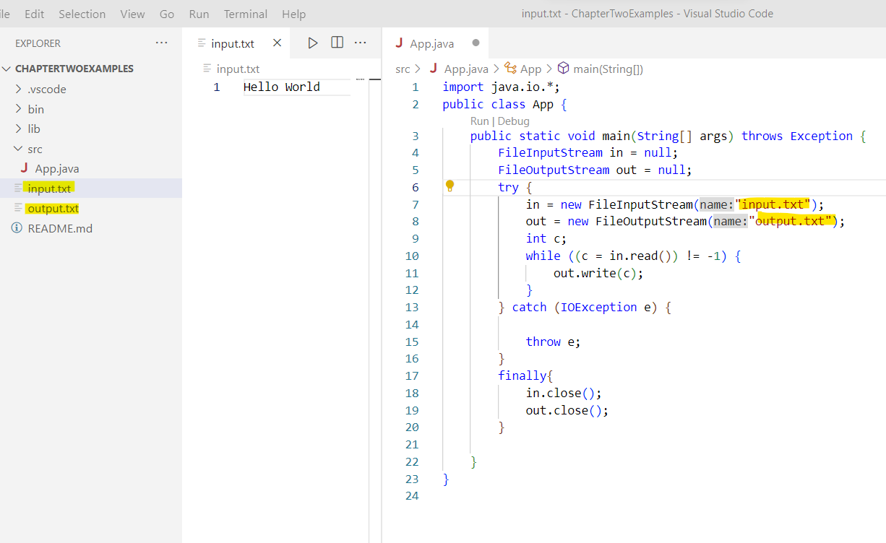
Example BufferInput Stream(Reading File Content)
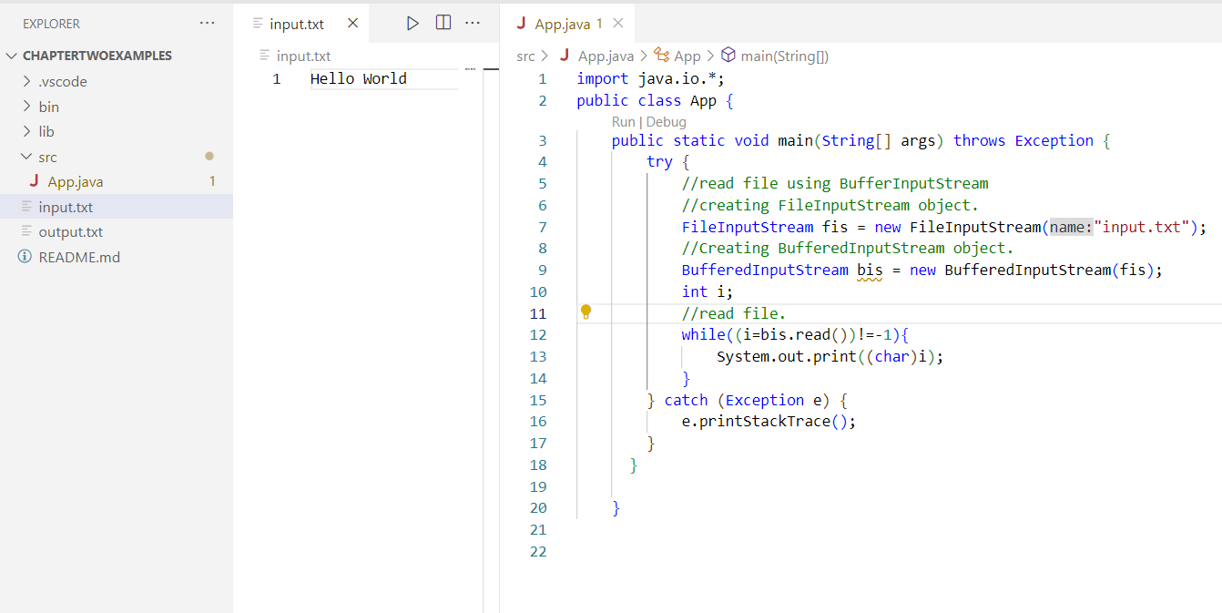

Example BufferOnput Stream(Writing to File)
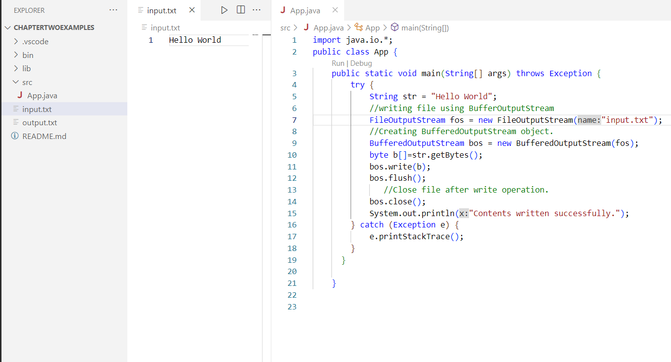

CharacterStreams:
Character streams in Java handle I/O operations at the character level, making them suitable for reading and writing text-based data. They are designed to handle character encoding and decoding automatically, allowing for the reading and writing of characters. Character streams work with the Reader and Writer classes
Types of CharacterStreams:
- Reader: The Reader class is an abstract base class for all character input streams. It defines methods for reading characters from a source and provides a common interface for working with character-based input streams. Some commonly used subclasses of Reader include FileReader, BufferedReader, StringReader, and InputStreamReader.
- Writer: The Writer class is an abstract base class for all character output streams. It defines methods for writing characters to a destination and provides a common interface for working with character-based output streams. Some commonly used subclasses of Writer include FileWriter, BufferedWriter, StringWriter, and OutputStreamWriter.
Character StreamsExample:

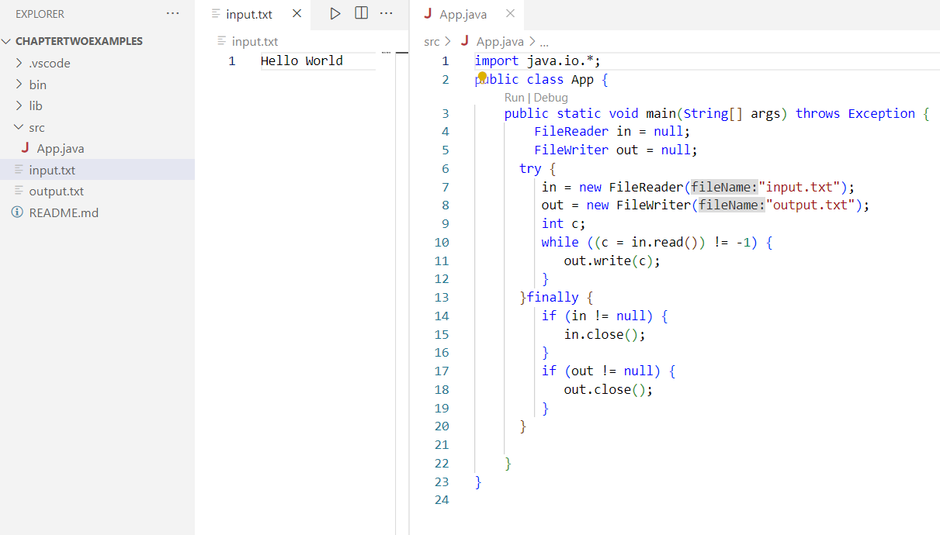

ByteStream Classes:

Stream class | Description
BufferedInputStream | It is used for Buffered Input Stream.
DataInputStream | It contains method for reading java standard datatypes.
FileInputStream | This is used to reads from a file
InputStream | This is an abstract class that describes stream input.
PrintStream | This contains the most used print() and println() method
BufferedOutputStream | This is used for Buffered Output Stream.
DataOutputStream | This contains method for writing java standard data types.
FileOutputStream | This is used to write to a file.
OutputStream | This is an abstract class that describe stream output.

CharacterStream Class

Stream class | Description
BufferedReader | It is used to handle buffered input stream.
FileReader | This is an input stream that reads from file.
InputStreamReader | This input stream is used to translate byte to character.
OutputStreamReader | This output stream is used to translate character to byte.
Reader | This is an abstract class that define character stream input.
PrintWriter | This contains the most used print() and println() method
Writer | This is an abstract class that define character stream output.
BufferedWriter | This is used to handle buffered output stream.
FileWriter | This is used to output stream that writes to file.

File and Directories:
List all file from directories
import java.io.*;
public class App {
public static void main(String[] args) throws Exception {
String directoryPath = "E:\\OOP in Java";
File directory = new File(directoryPath);
File[] files = directory.listFiles();
if (files != null)
{
for (File file : files) {
System.out.println(file.getName());
}
}
else
{
System.out.println("No files in the directory.");
}
}
}
Create New File:
import java.io.*;
public class App {
public static void main(String[] args) throws Exception {
File file = new File("newfile.txt");
try
{
file.createNewFile();
} catch (IOException e)
{
System.out.println("An error occurred: ");
}
}
}

Copy File:
import java.io.*;
import java.nio.file.*;
public class App {
public static void main(String[] args) throws Exception {
String sourceFilePath = "E://OOP in Java//Threads.docx";
String destinationFilePath = "E://OOP in Java//Sample Questions//Threads.docx";
Path sourcePath = Paths.get(sourceFilePath);
Path destinationPath = Paths.get(destinationFilePath);
try {
Files.copy(sourcePath, destinationPath);
System.out.println("File copied successfully!");
} catch (IOException e) {
System.out.println("An error occurred: " + e.getMessage());
}
}
}
Delete File:
import java.io.*;
import java.nio.file.*;
public class App {
public static void main(String[] args) throws Exception {
String filePath = "E://OOP in Java//Threads.docx";
Path path = Paths.get(filePath);
try {
Files.delete(path);
System.out.println("File deleted successfully!");
} catch (IOException e) {
System.out.println("An error occurred: " + e.getMessage());
}
}
}

Object Serialization:
Object serialization is the process of converting an object into a byte stream, which can be saved to a file, sent over a network, or stored in a database. It is mainly used in Hibernate, RMI (Remote Method Invocation), JPA (Java Persistence API), EJB (Enterprise Java Beans) and JMS (Java Message Service) technologies.
The reverse operation of serialization is called deserialization where byte-stream is converted into an object. The serialization and deserialization process is platform-independent, it means you can serialize an object on one platform and deserialize it on a different platform.
For serializing the object, we call the writeObject() method of ObjectOutputStream class, and for deserialization we call the readObject() method of ObjectInputStream class.
Syntax for the writeObject() method:
public final void writeObject(Object o) throws IO Exception
Syntax for the readObject() method:
public final Object readObject() throws IOException, ClassNotFoundException

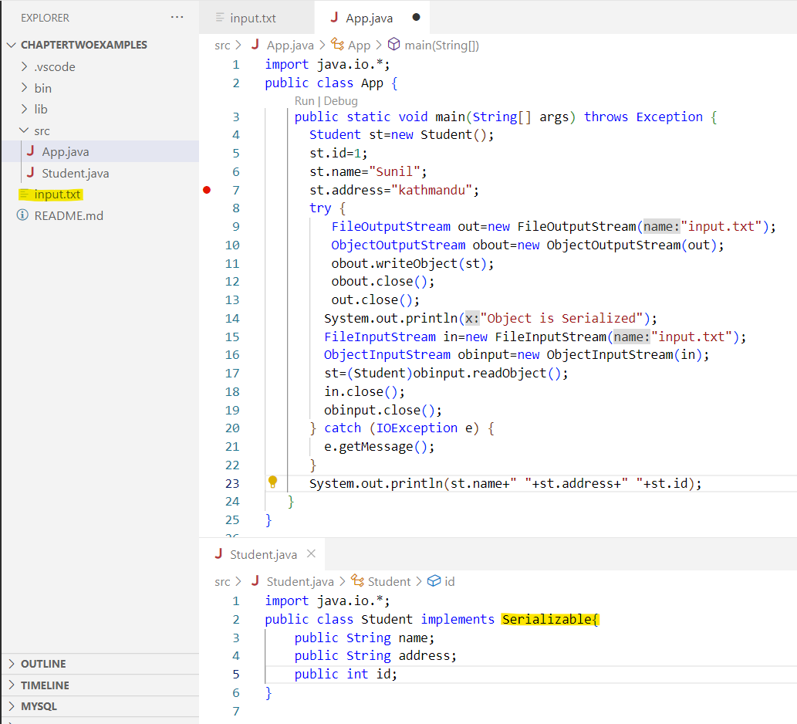

RandomAccessFile

The RandomAccessFile class is used to perform random access to a file. Unlike other file handling classes like FileInputStream or FileOutputStream, which provide sequential access to a file, RandomAccessFile allows you to read from or write to any position within the file.

To work with a file using RandomAccessFile, you first need to create an instance of the class. You can do this by providing the file path and the mode (read-only, write-only, or both) as parameters to the constructor.

There are two modes: "r" for reading and "rw" for reading and writing.
Reading from a RandomAccessFile:
RandomAccessFile raf = new RandomAccessFile("example.txt", "r");
byte[] buffer = new byte[1024];
int bytesRead = raf.read(buffer);

Writing To a RandomAccessFile:
RandomAccessFile raf = new RandomAccessFile("example.txt", "rw");
byte[] data = "Hello, World!".getBytes();
raf.write(data);

Moving Pointer:
raf.seek(50);

Closing RandomAccessFile:
raf.close();

Example:
import java.io.*;
public class App {
public static void main(String[] args)
{
String FILEPATH ="input.txt";
try {
System.out.println(new String(readFromFile(FILEPATH, 0, 18)));
writeToFile(FILEPATH, "Stay positive. Better days are on their way.", 31);
System.out.println(new String(readFromFile(FILEPATH, 0,100)));
} catch (IOException e) {
e.printStackTrace();
}
}

private static byte[] readFromFile(String filePath, int position, int size)
throws IOException {
RandomAccessFile file = new RandomAccessFile(filePath, "r");
file.seek(position);
byte[] bytes = new byte[size];
file.read(bytes);
file.close();
return bytes;
}
private static void writeToFile(String filePath, String data, int position)
throws IOException {
RandomAccessFile file = new RandomAccessFile(filePath, "rw");
file.seek(position);
file.write(data.getBytes());
file.close();
}
}

